IBM ASSIGNMENT 1

**VISULIZATION THE DATA SET**

ABISH D P

B.Tech – INFORMATION TECHNOLOGY

CAPE INSTITUTE OF TECHNOLOGY



# IBM COGNOS ANALYTICS WITH WATSON

* R & D SPEND BY STATE
* ADMINISTRATION BY R&D SPEND
* R&D SPEND AND R&D SPEND COLORED BY
* ADMINSTRATION

MARKET SPEND FOR R&D SPEND

* ADMINISTRATION BY R&D SPEND COLORED BY STATE
* R&D SPEND COLORED BY STATE SIZED BY ADMINISTRATION

**R & D SPEND BY STATE**

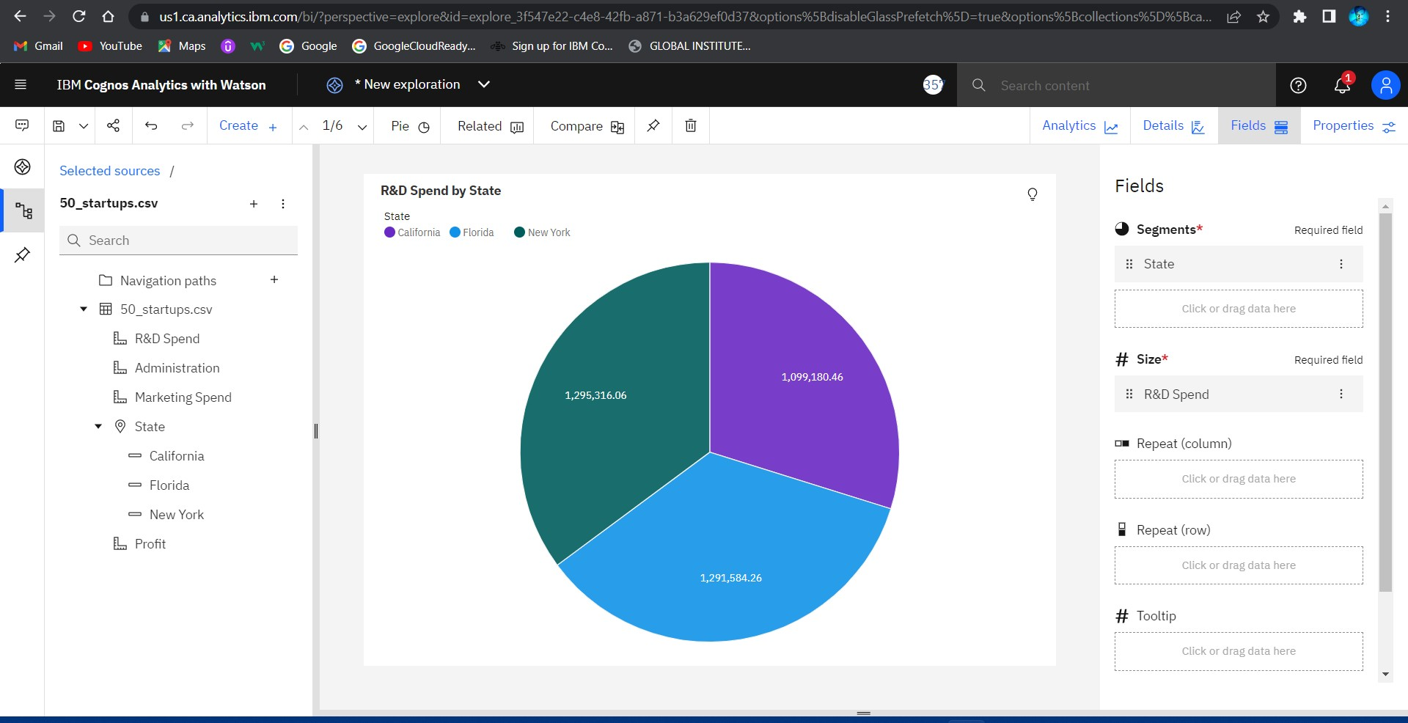

**ADMINISTRATION BY R&D SPEND**

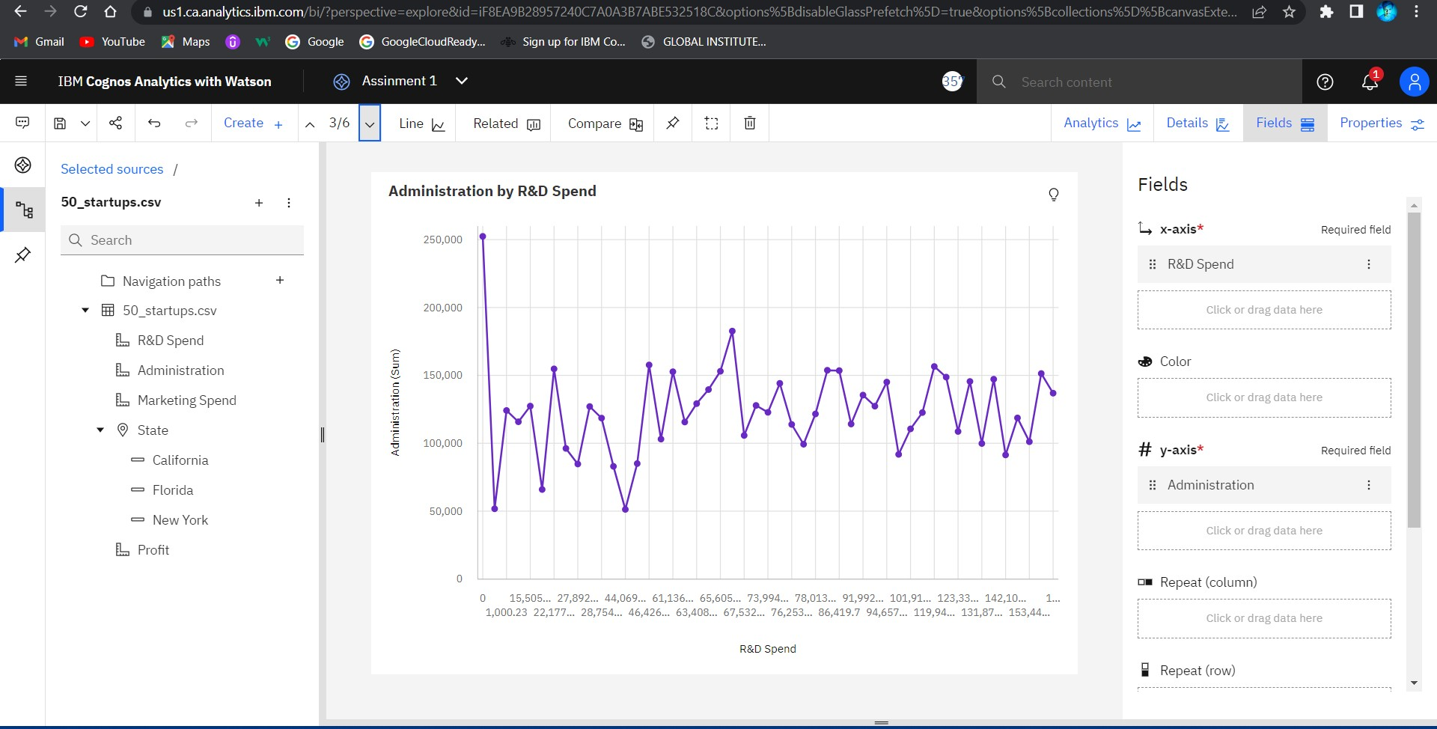

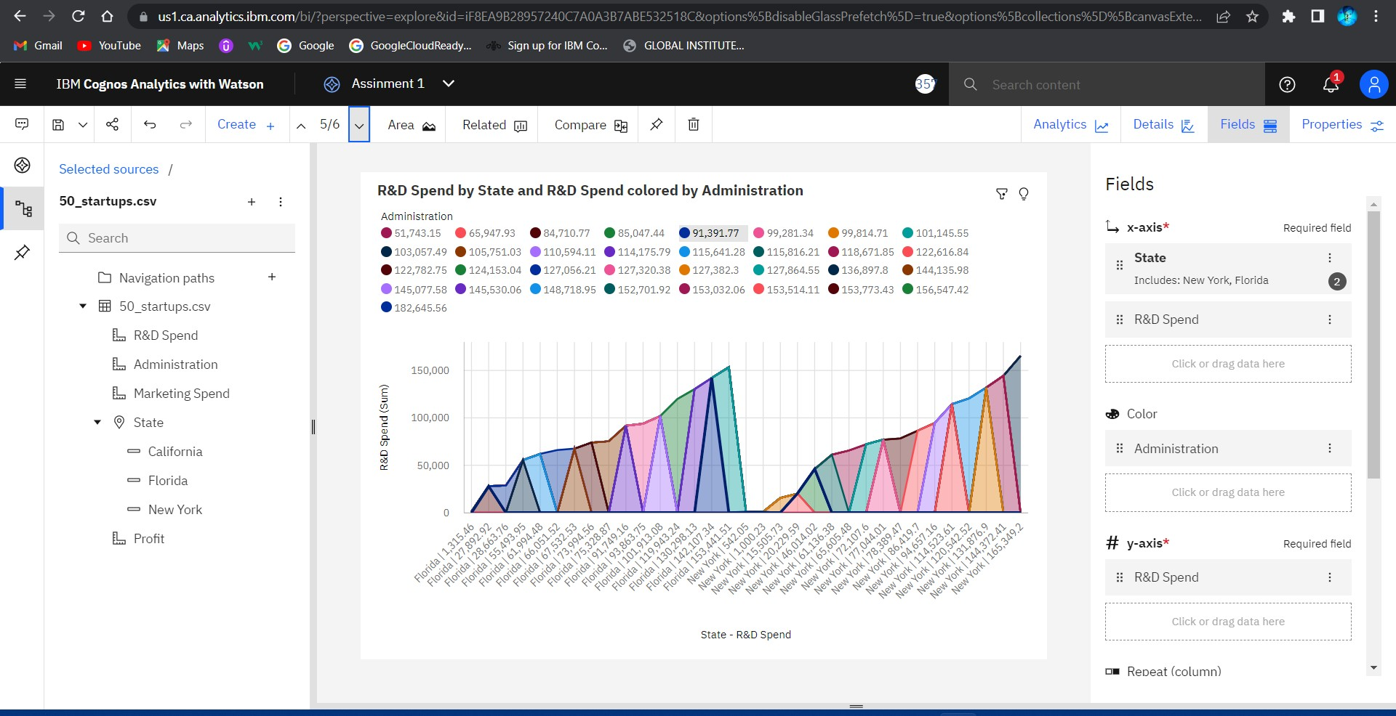**R&D SPEND AND R&D SPEND COLORED BY ADMINSTRATION**

**MARKET SPEND FOR R&D SPEND**

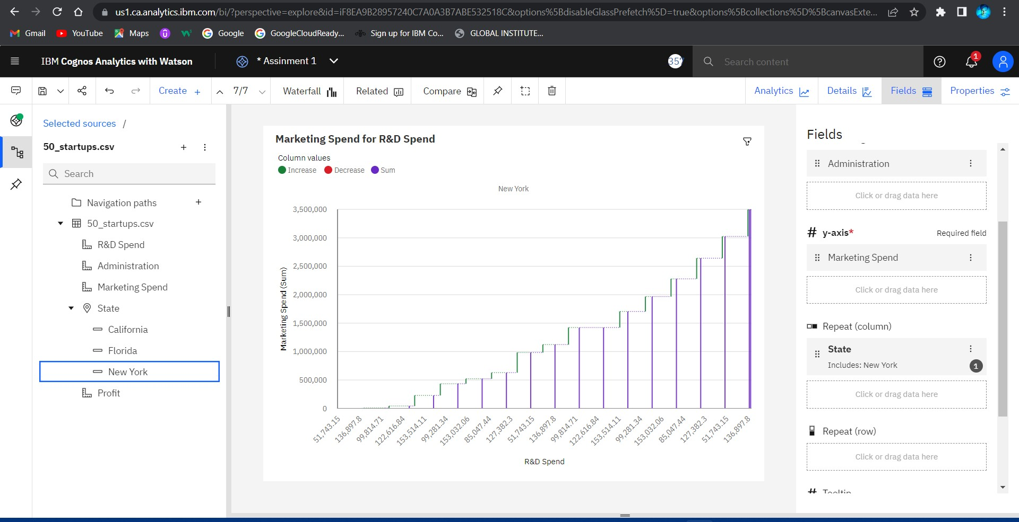

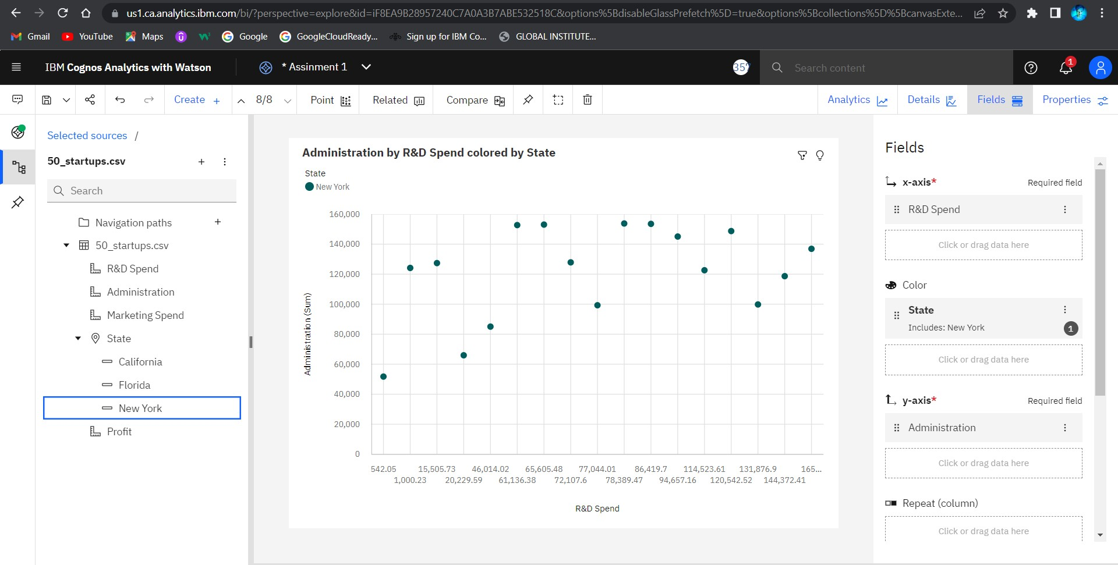**ADMINISTRATION BY R&D SPEND COLORED BY STATE**

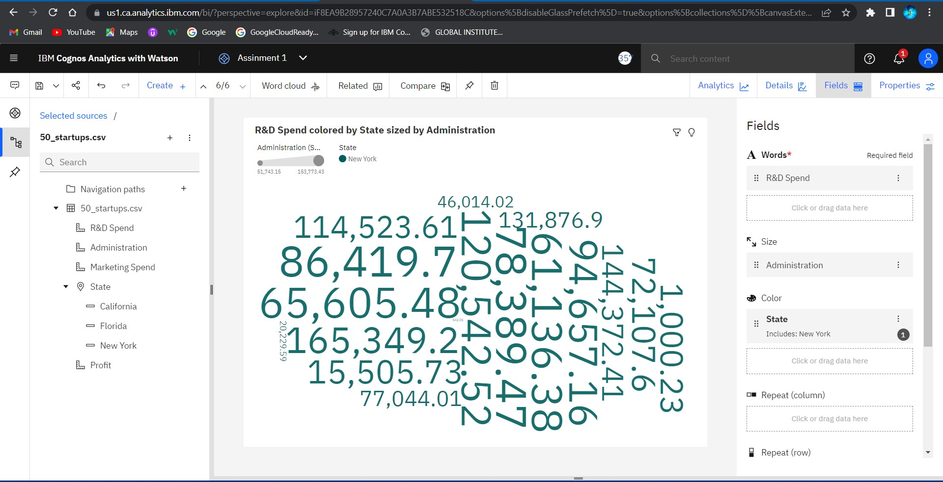**R&D SPEND COLORED BY STATE SIZED BY ADMINISTRATION**

**LINK TO OPEN MY DATA VISUALIZATON IN THE COGNOS ANALYTICS**

**https://us1.ca.analytics.ibm.com/bi/?perspective=explore&pathRef=. my_folders%2FData%2Bmodule%2FAssinment%2B1&subView=mo del000001834581004e_00000004**